ISPOR Graduation Cords
(Available while supplies last!)
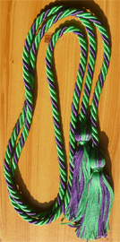
- An ISPOR Student Member benefit

Date submitted: ________________________________________
ISPOR Student Chapter: _____________________________________________________________
Qty of Cords: ________
ISPOR Student Members requesting a graduation cord: (Please note active membership will be verified)
ISPOR Student Member Name: | ISPOR Student Member ID #:
If you have additional names, please add rows to this document.
Student Chapter President mailing address for cord distribution:
Name: ____________________________________________________________________________
Address: __________________________________________________________________________
__________________________________________________________________________________
Date to receive cords by: _________________________________
Please allow up to two weeks lead time so we can confirm membership and depending on where the package is being shipped to.

Return this form along with the materials order form to StudentNetwork@ispor.org.

